Karthikeyan Rajamani

UTA ID: 1001267157

CSE5345

Lab1-OPNET

# 1.1 Scenario1

Date Rate: 24Mbps

RTS Threshold: 800 bytes

Packet size: 500 bytes

Station 1 will be serving as receiving station, without sending out its own traffic. 5 other stations will be sending traffic destined to Station 1. For all the 5 stations, packet size shall be set to constant 500bytes. Set RTS threshold to be 800 bytes in the WLAN parameters. Do not change physical layer parameters (e.g. data rate).

Network throughput (data packets successfully received in packets/second or bits/second). You should use moving average to show a smooth figure

## Receiver settings:

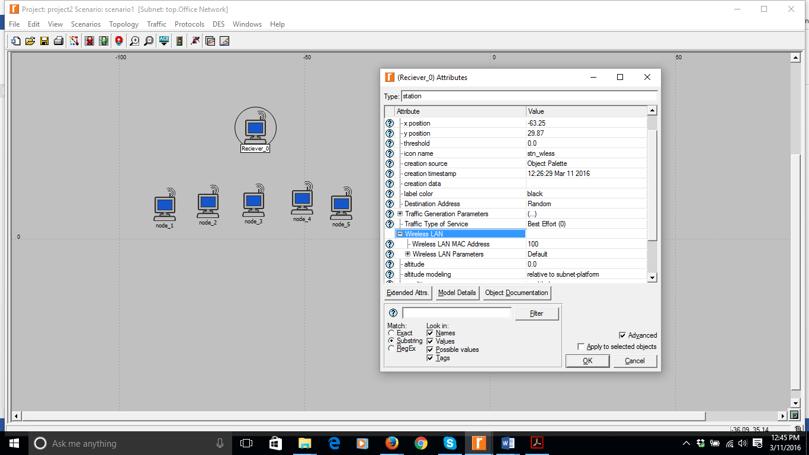

## Transmitter settings:

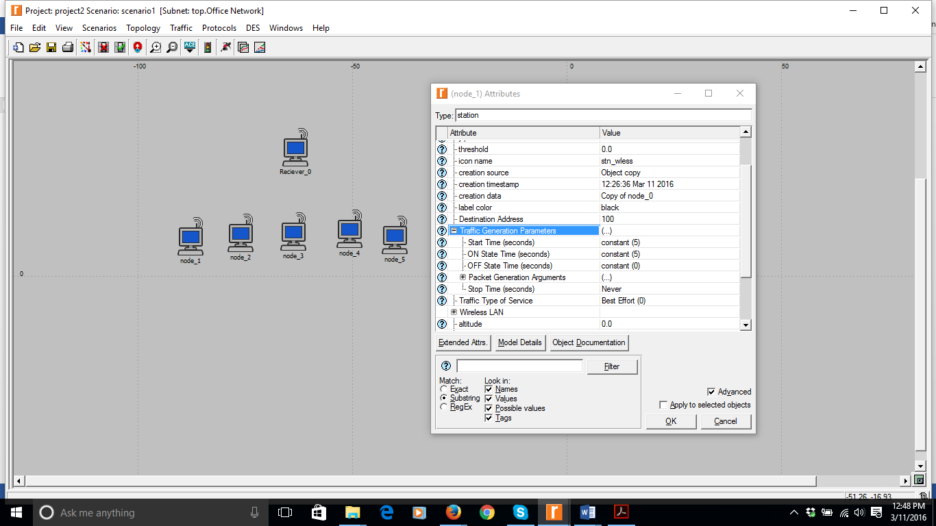

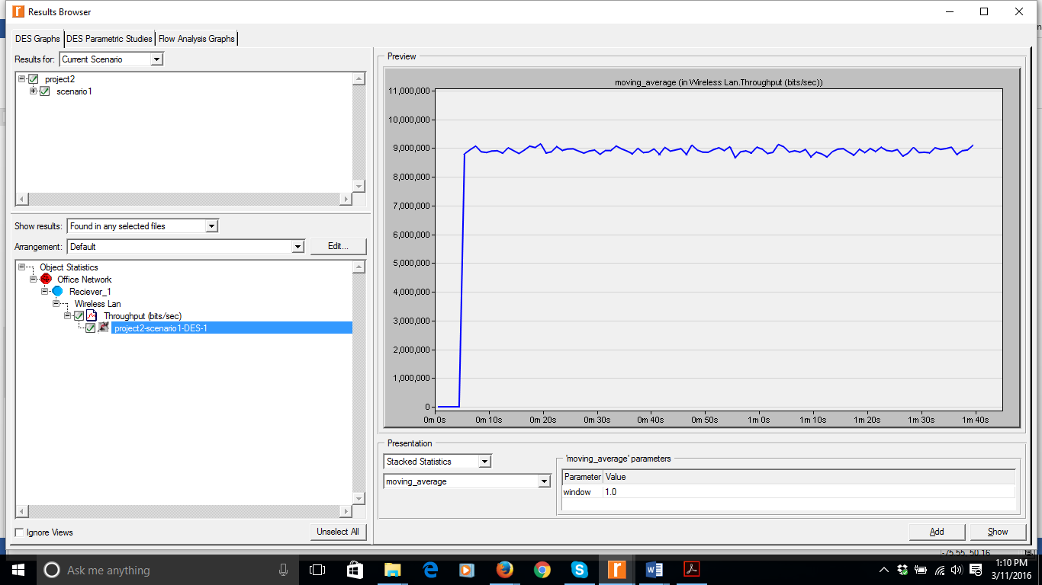

Throughput =9,000,000 (Around)

# 1.2 Scenario2

Date Rate: 24Mbps

RTS Threshold: 800 bytes

Packet size: 1500 bytes

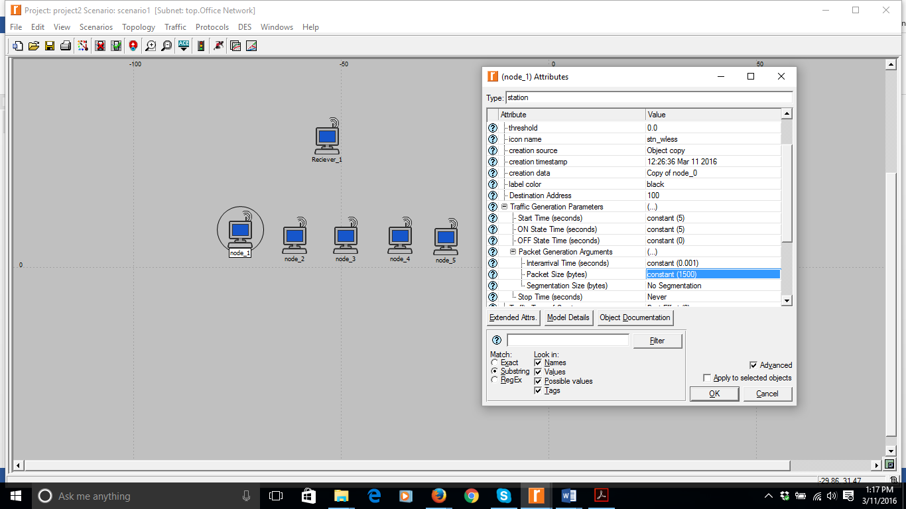

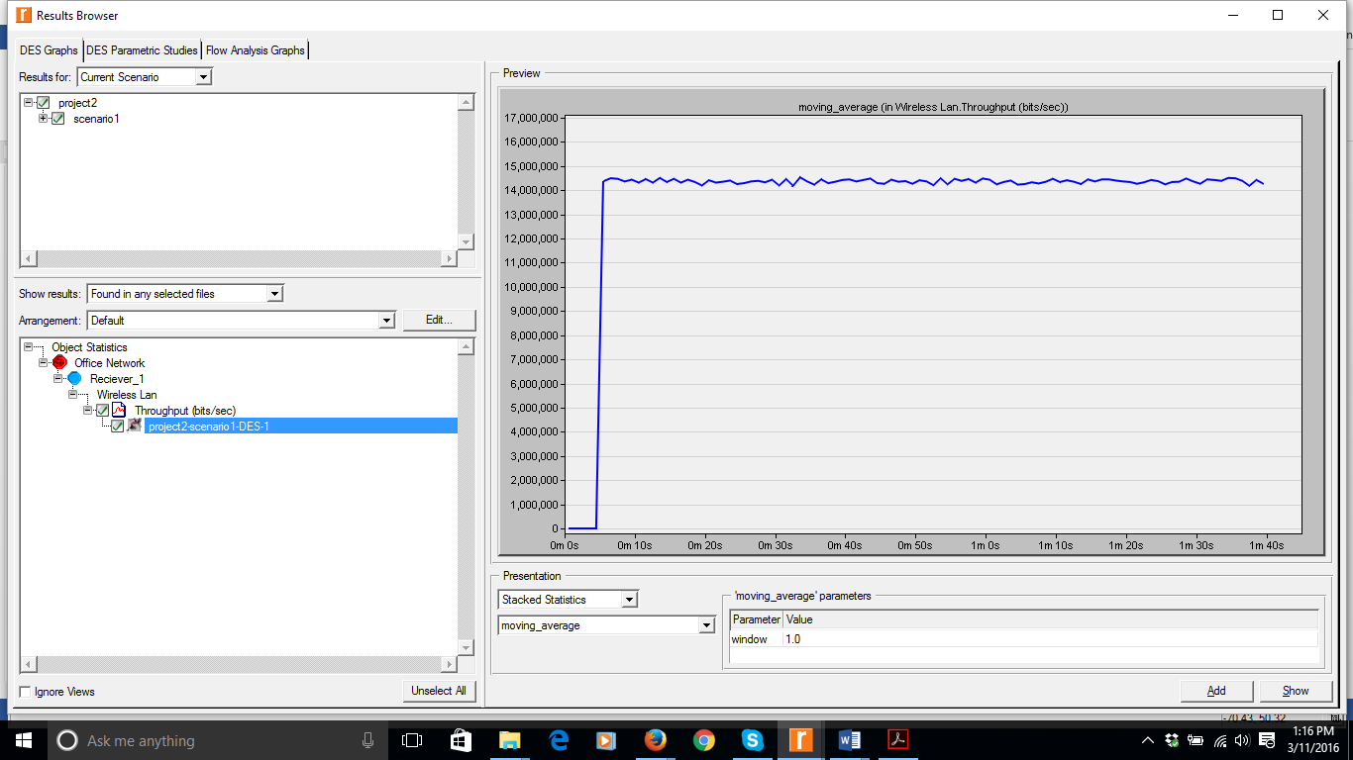

Throughput: 14,000,000 (Approx.)

# 1.3 Scenario3

Packet size: 500 bytes

Throughput for two individual nodes respectively (data packets successfully received in packets/second or bits/second). You may not be able to observe this directly but you should be able to figure out how to collect this information indirectly.

Introducing another receiver to measure Throughput of the individual nodes.

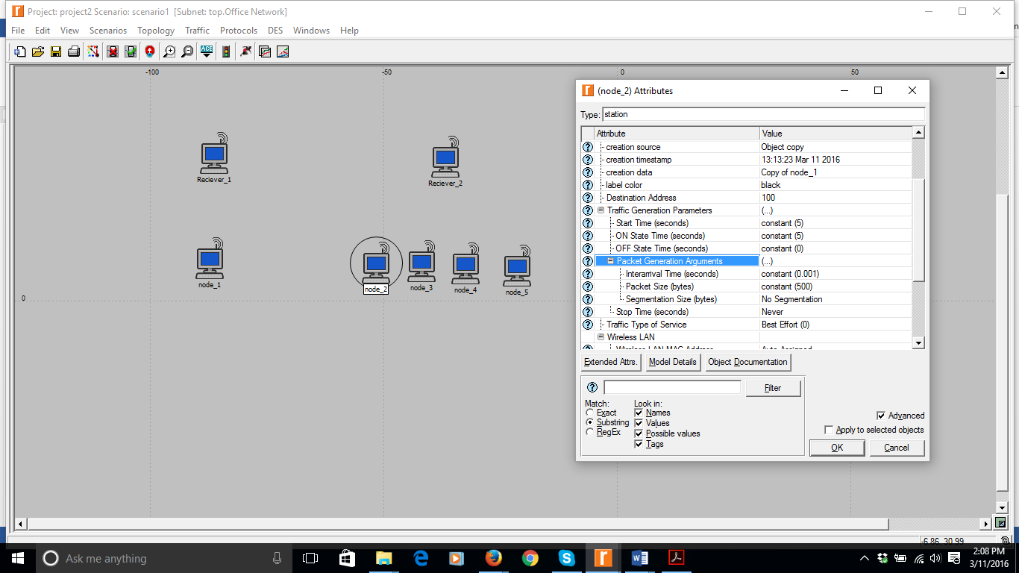

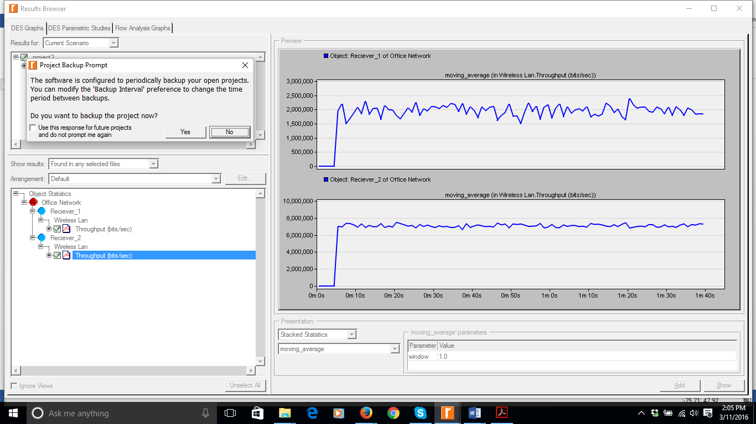

Throughput of Reciever1:2,000,000

Throughput of Reciever2:7,000,000

# 1.4 Scenario4

Packet size: 1500 bytes

Throughput for two individual nodes respectively (data packets successfully received in packets/second or bits/second). You may not be able to observe this directly but you should be able to figure out how to collect this information indirectly.

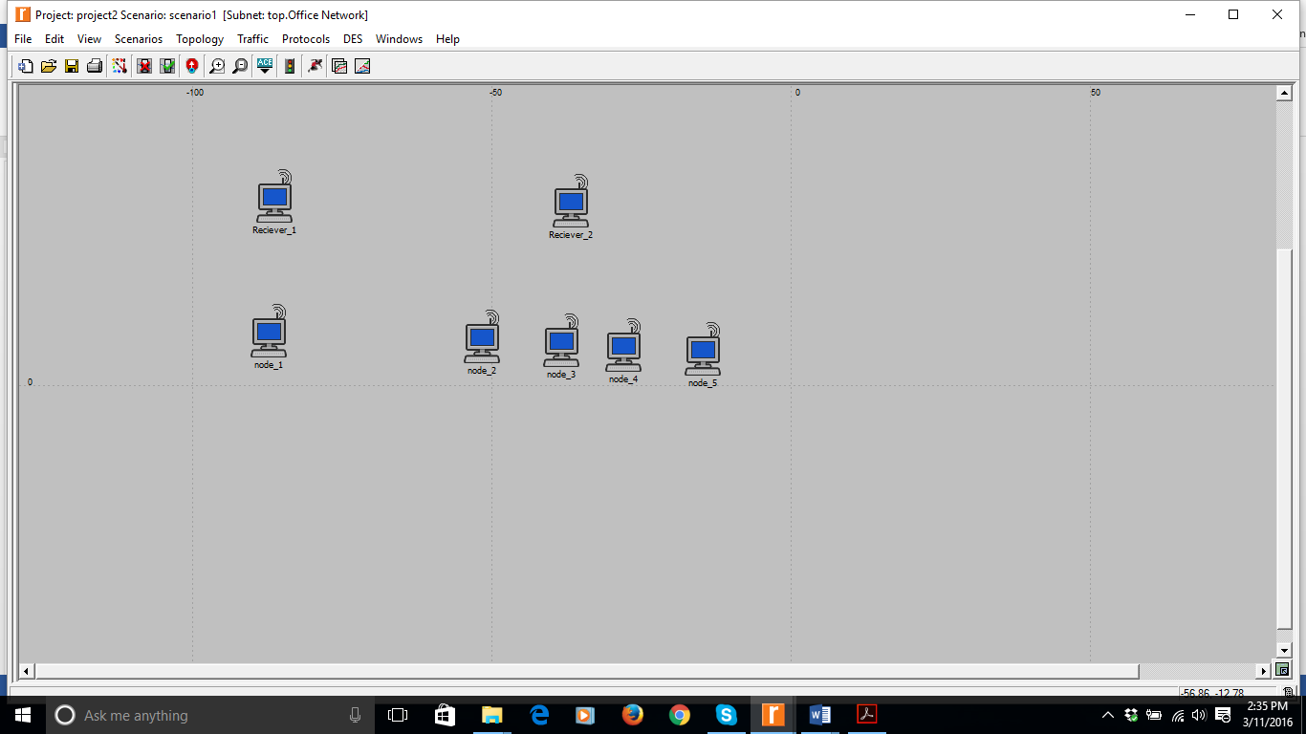

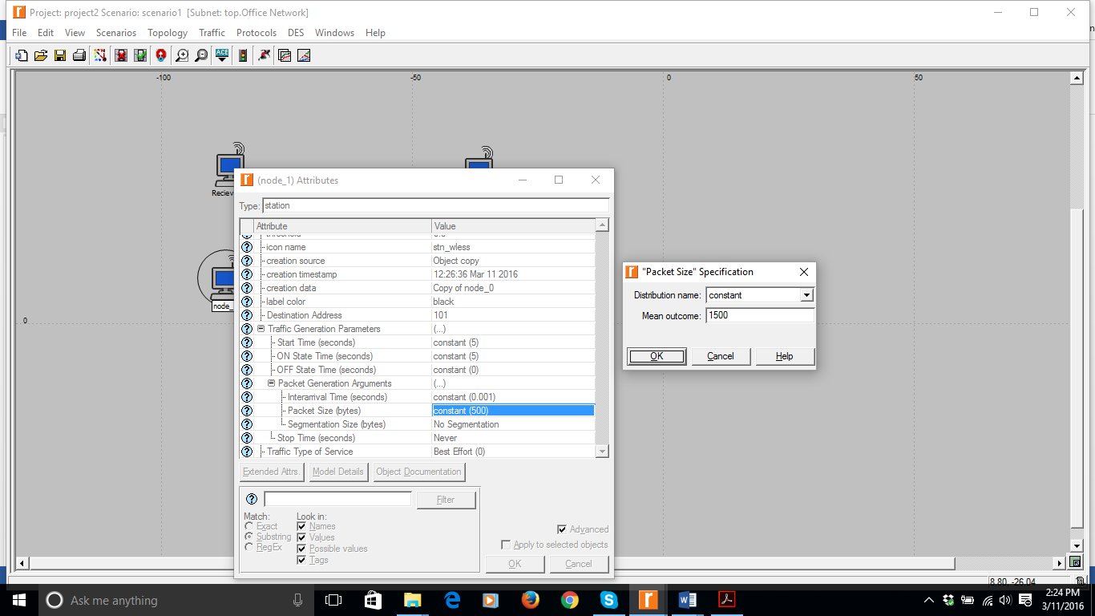

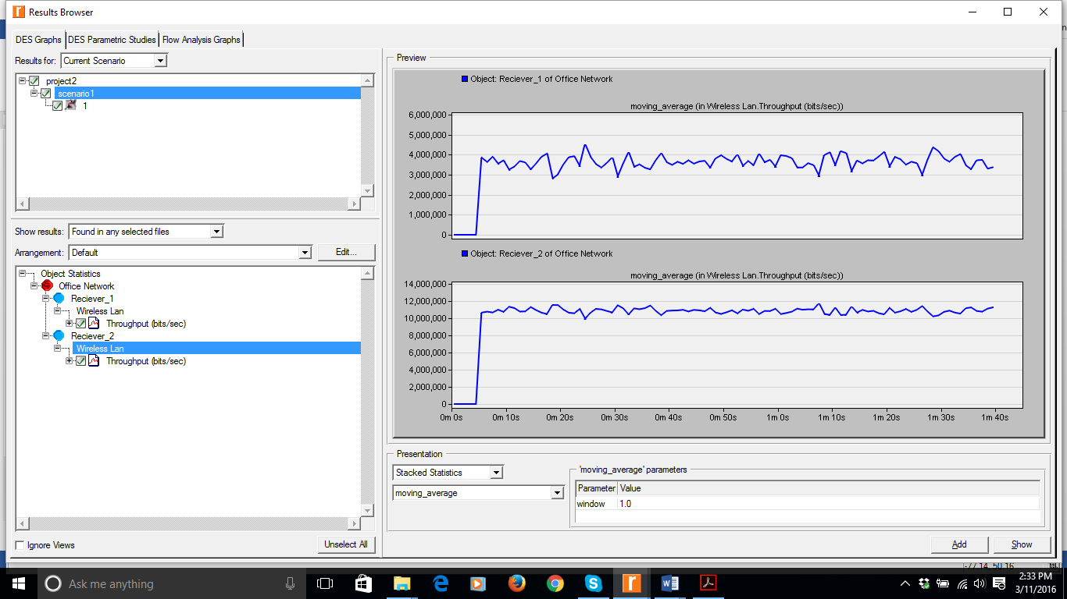

Throughput of Node1 sending to Reciever1= 3500000 Approx

# 2.1 Scenario5

1. 10 Nodes sending to one receiver
2. Packet size=500 Bytes

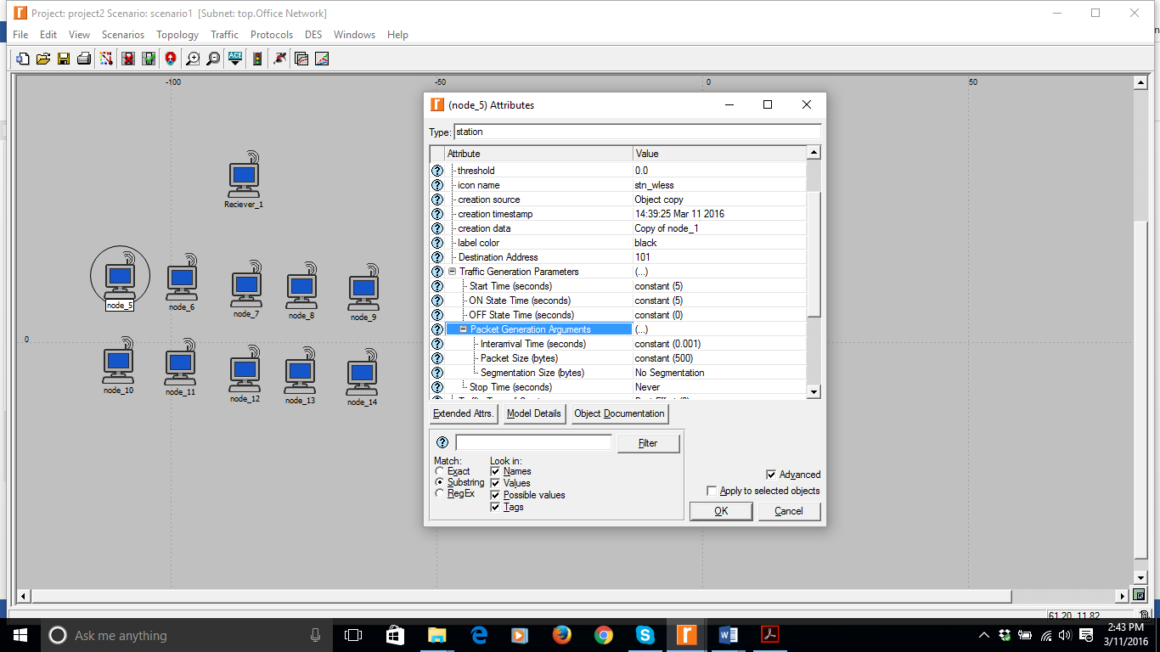

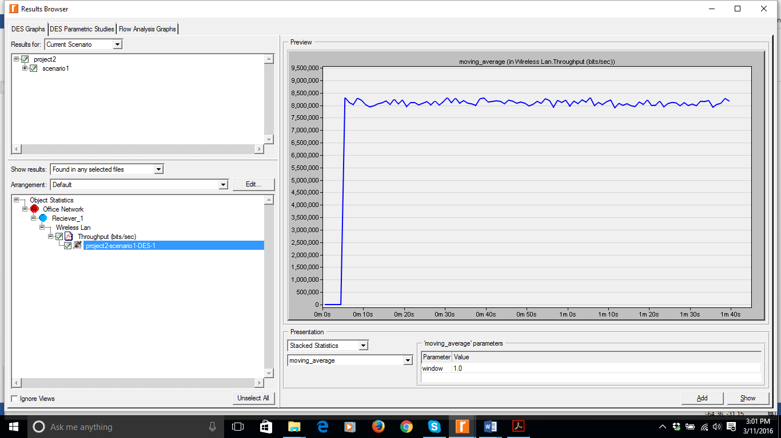

Throughput=8,000,000 Approx

# 2.2 Scenario6

1. 10 Nodes sending to one receiver
2. Packet size=1500 Bytes

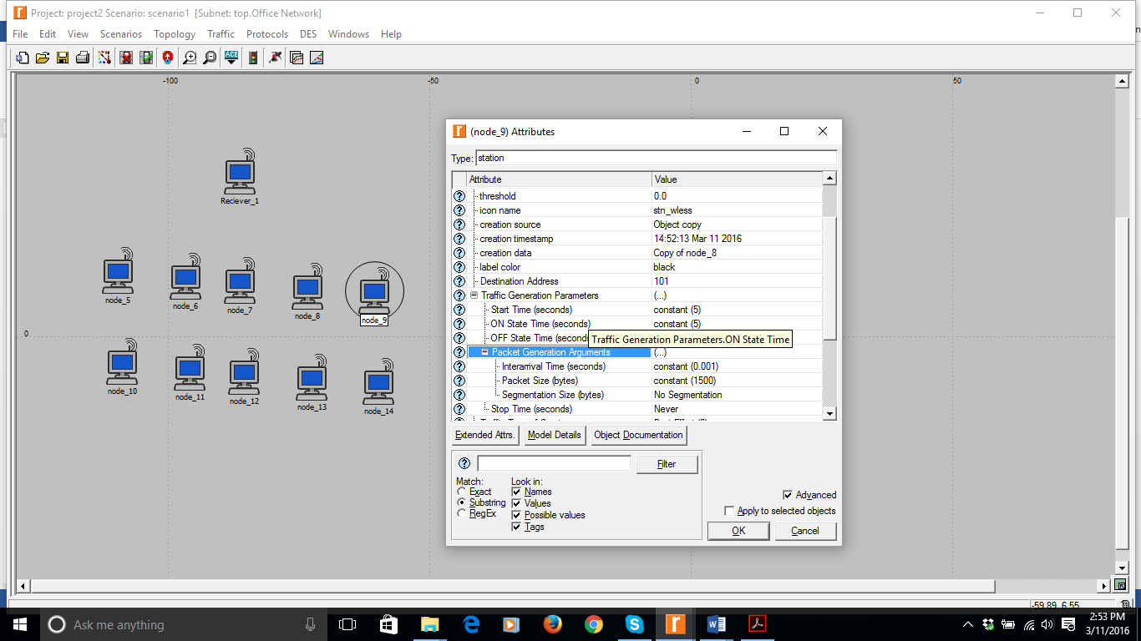

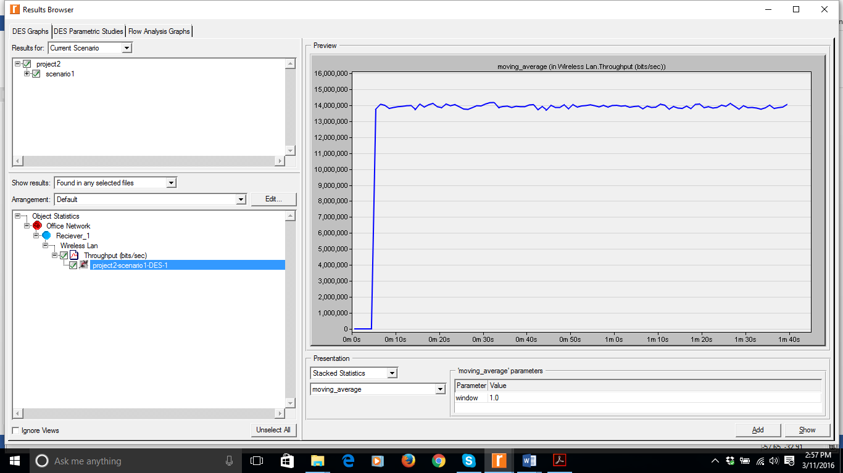

Throughput =14,000,000

# 2.3 Scenario7

1. 9 Nodes sending to one receiver
2. 1 Node sending to one receiver
3. Packet size=500 Bytes

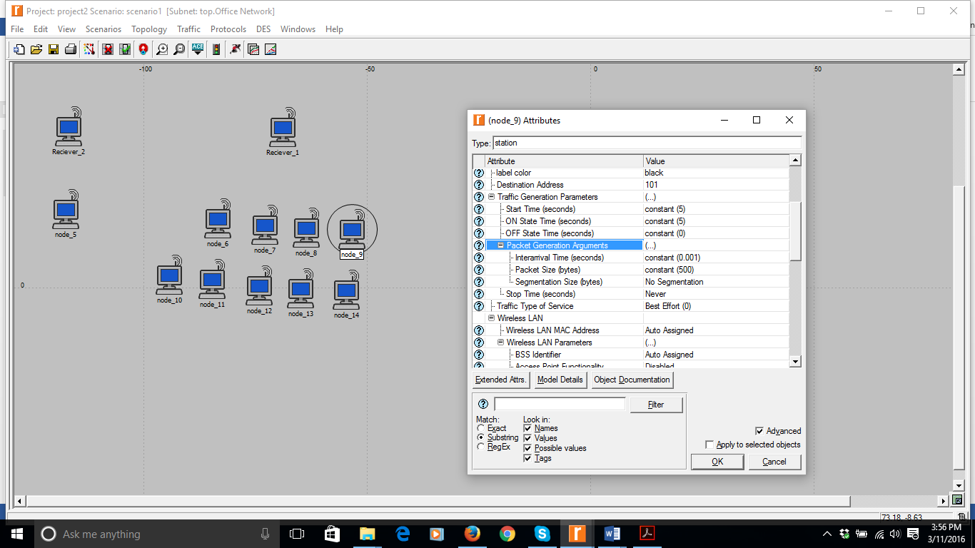

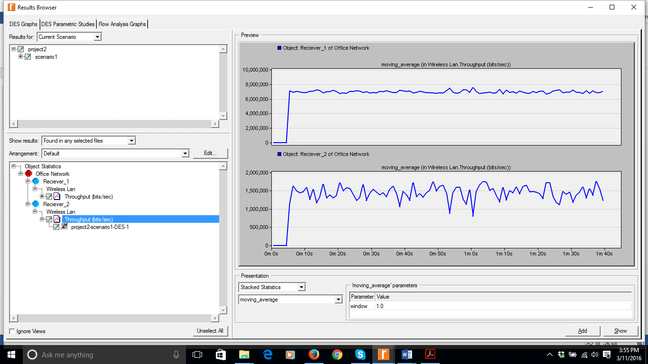

* Throughput of Node5 sending to Reciever2 is 8000000
* Throughput of all the other nodes sending to Reciever1 is 1500000

# 2.4 Scenario8

1. 9 Nodes sending to one receiver
2. 1 Node sending to one receiver
3. Packet size=1500 Bytes

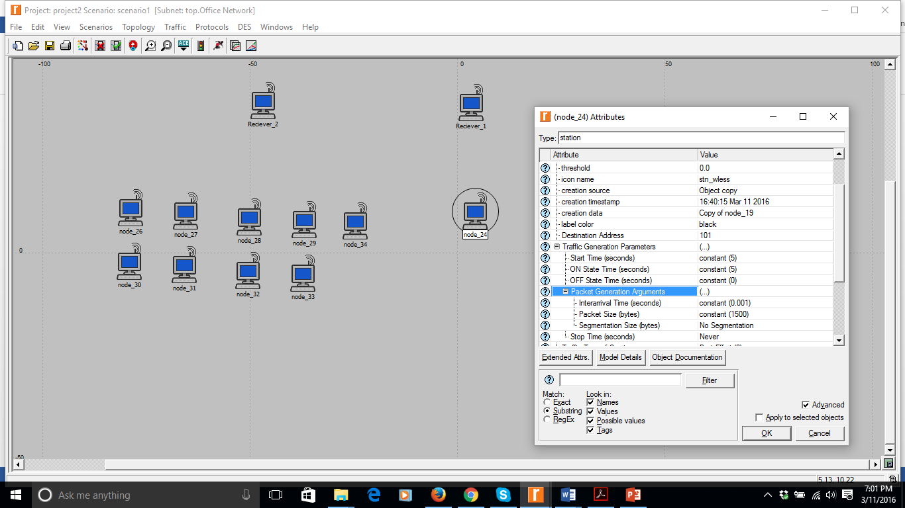

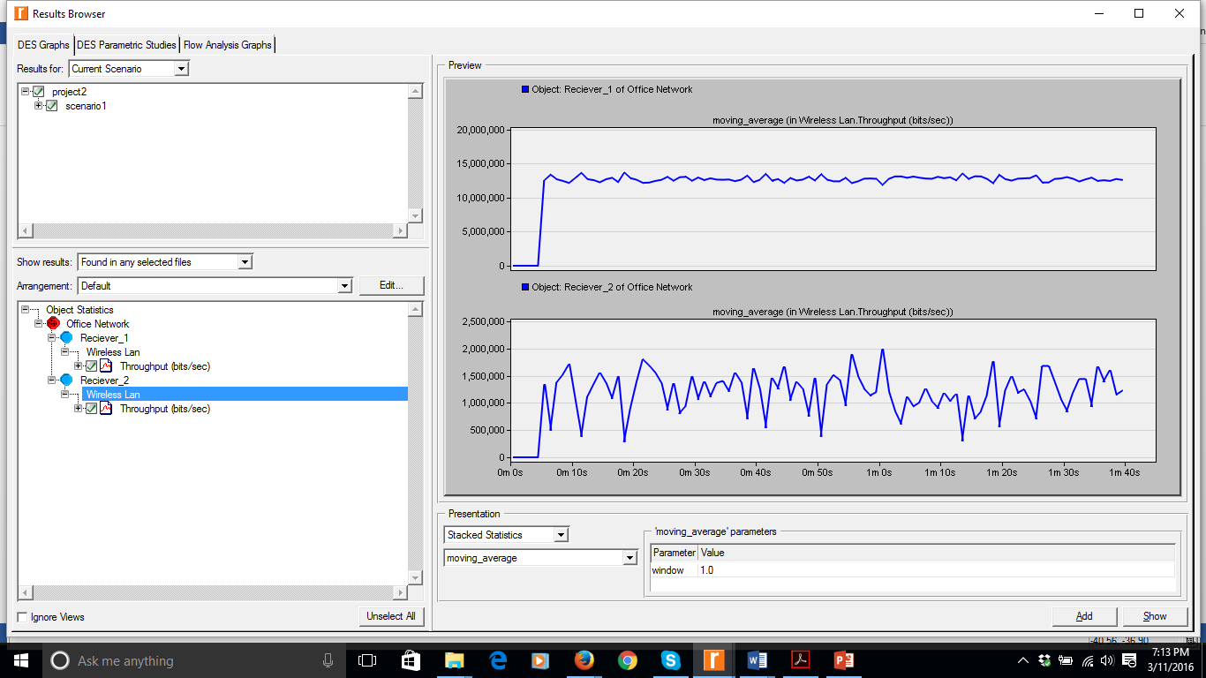

* Throughput of Node5 sending to Reciever1 is 14,000,000
* Throughput of all the other nodes sending to Reciever1 is 1,500,000

# 3.1 Scenario9

1. 20 Nodes sending to one receiver
2. Packet size=500 Bytes

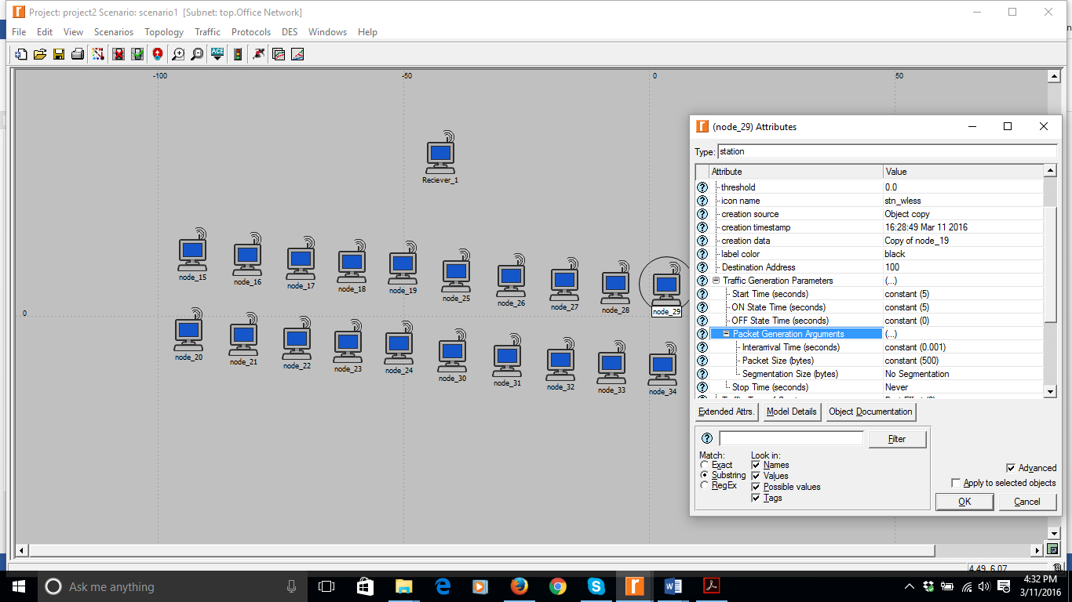

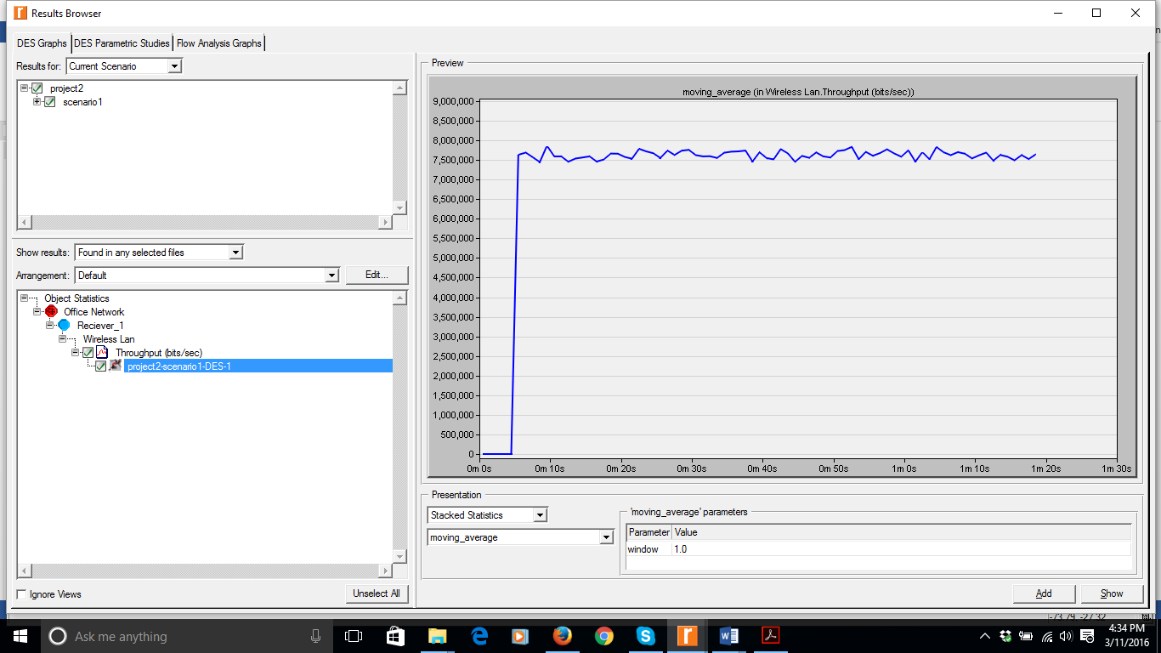

Throughput at receiver station is 7,500,000 Approx.

# 3.2 Scenario10

1. 20 Nodes sending to one receiver
2. Packet size=1500 Bytes

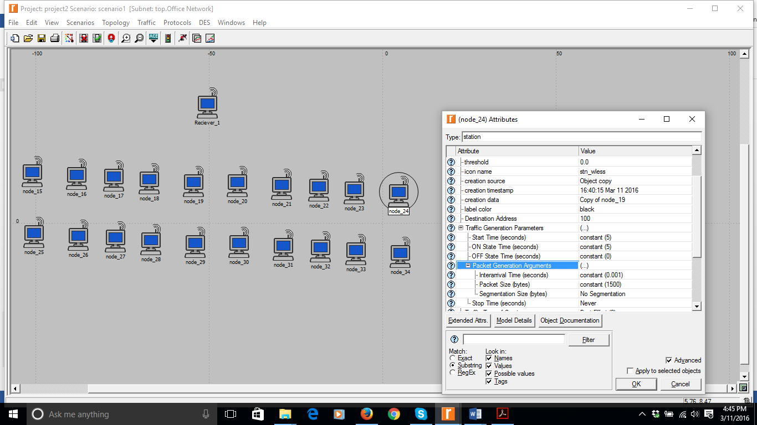

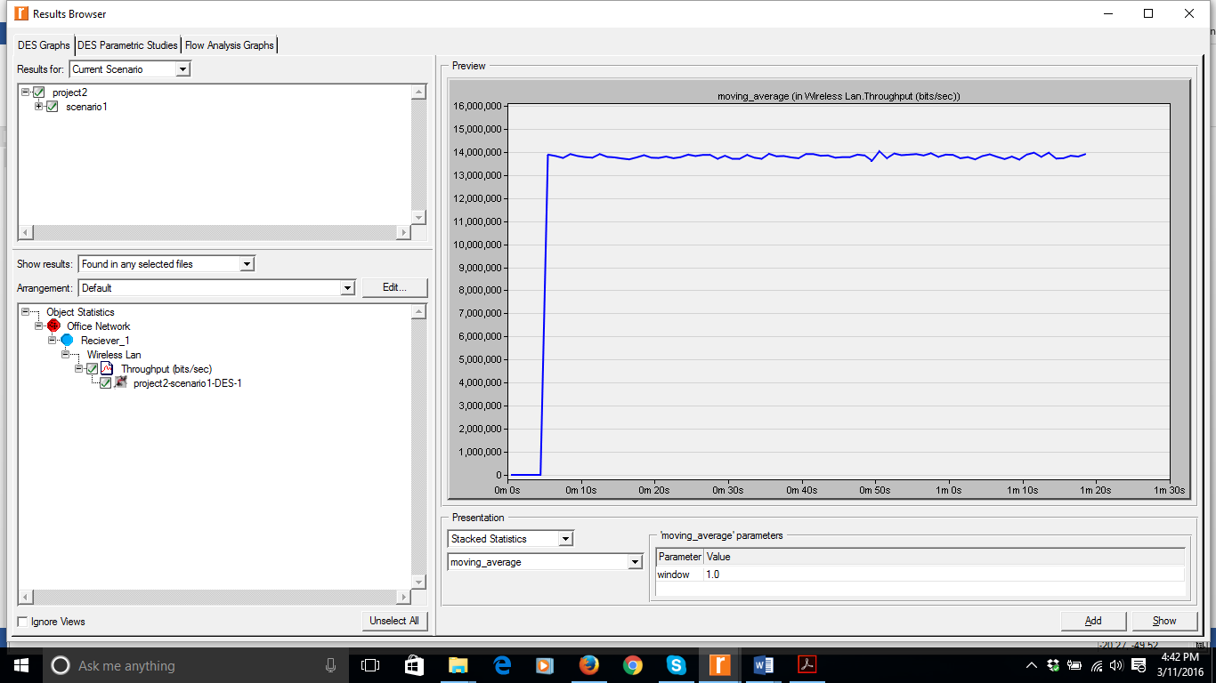

Throughput at receiver station is 14,000,000 Approx.

# 3.3 Scenario11

1. 19 Nodes sending to one receiver
2. 1 Node sending to one receiver
3. Packet size=500 Bytes

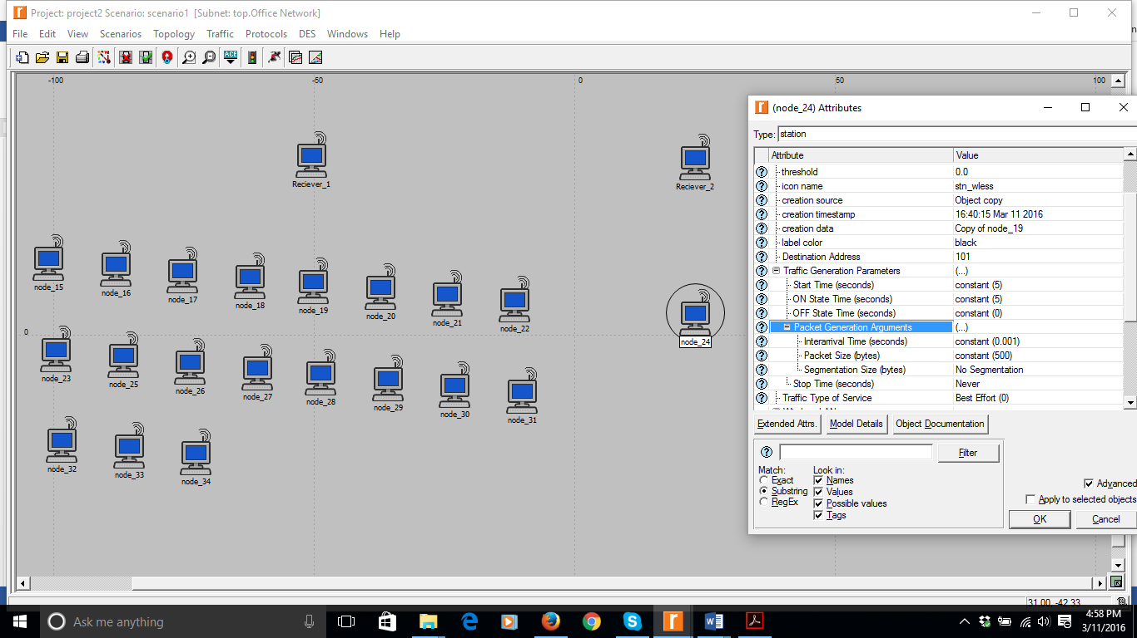

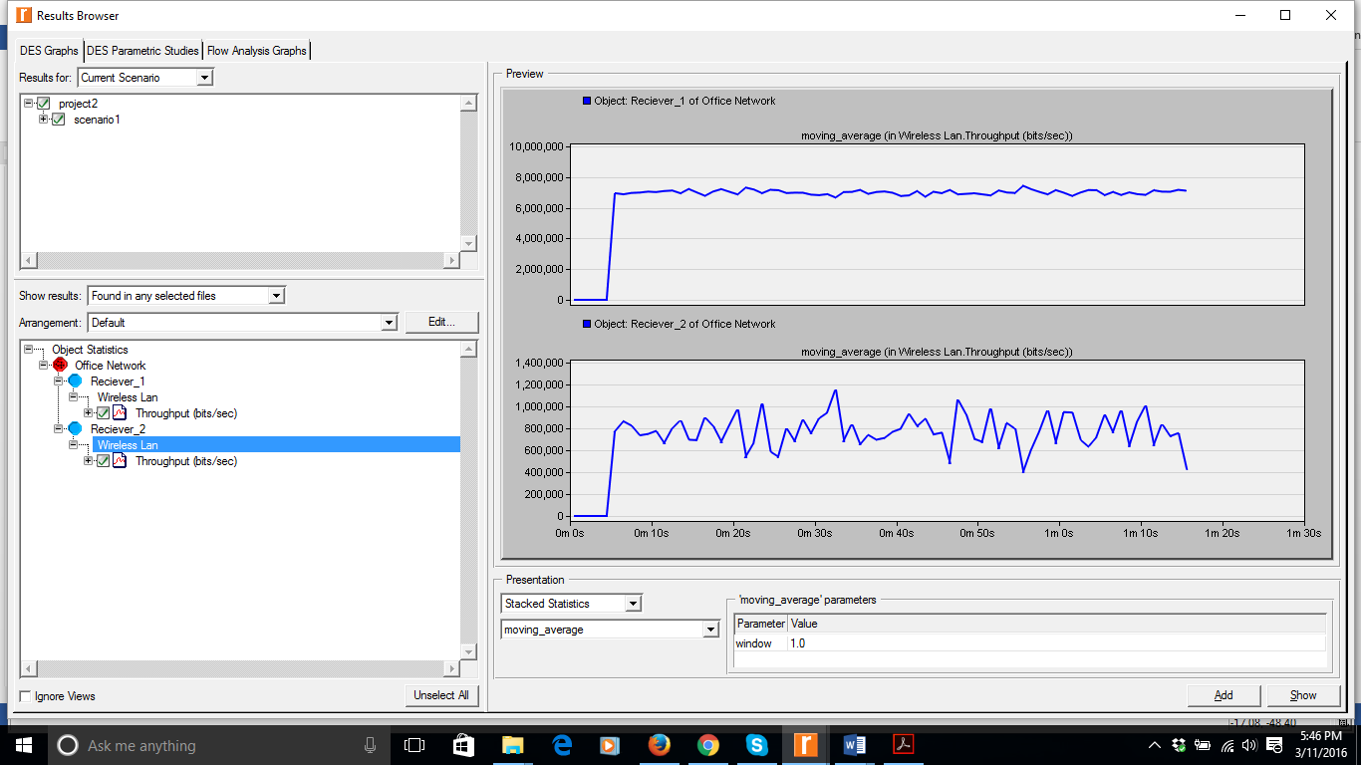

* Throughput at Receiver1=7,500,000 Approx.
* Throughput ate Receiver2=800,000 Approx.

# 3.4 Scenario12

1. 19 Nodes sending to one receiver
2. 1 Node sending to one receiver
3. Packet size=1500 Bytes

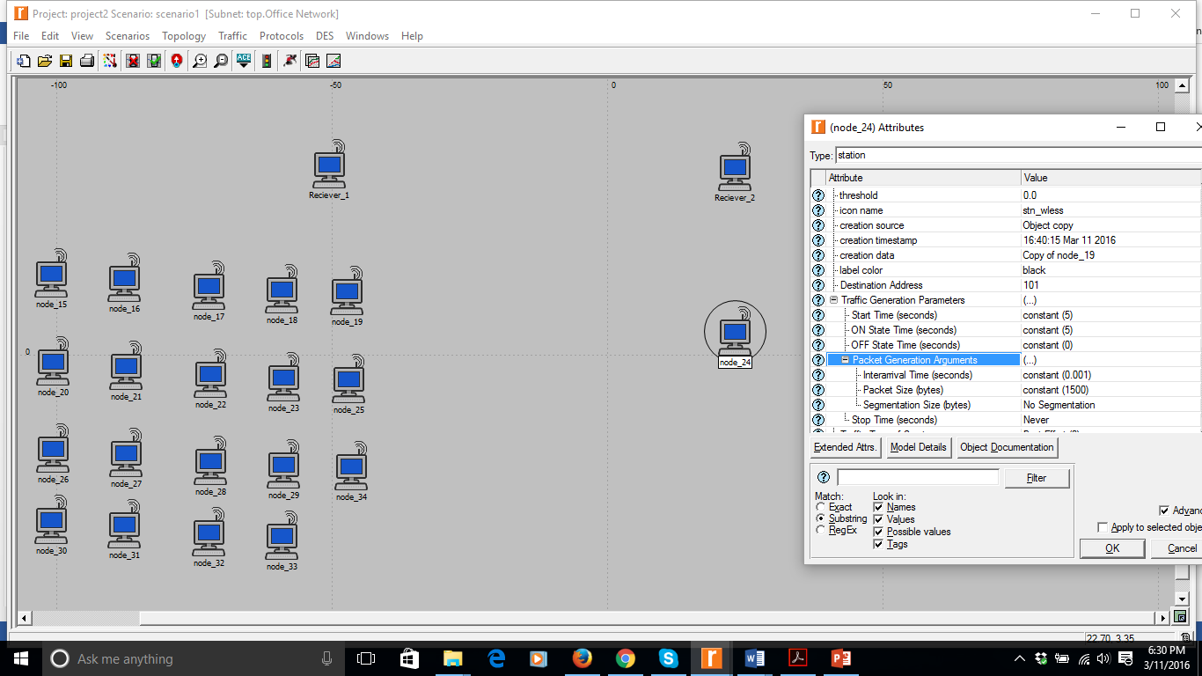

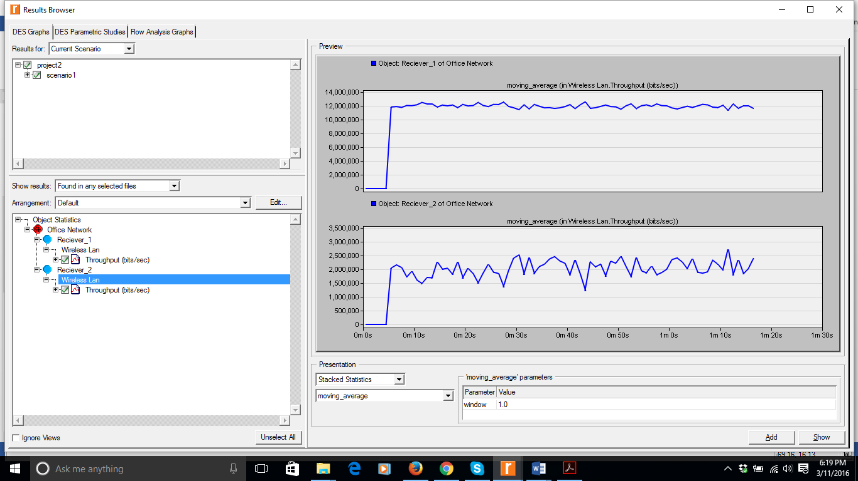

* Throughput at Receiver1=12,000,000 Approx.
* Throughput ate Receiver2=2,000,000 Approx.